








AIRBAND AUGUST NEWSLETTER
Bringing Ultrafast Broadband
TO YOUR AREA

Summer is here and we are well on our way! - We have boots on the ground either through the design and survey or, where our teams have now started the fibre build within your area. Of course, we will keep you updated throughout the project build and let you know how things are getting as this continues!

So, here is where we are! –The current Cheddon Fitzpaine project plan is in its ”In Build” phase with an anticipated build completion date in Quarter 3, 2021.

The Airband Community Liaison Role - I am sure that this will raise some interest and curiosity from your parishioners as this project build continues. My role is to purely liaise with the Parish Council and parishioners alike, to ensure we provide a continual communication flow from start to finish of the fibre broadband project within your area. You also have a direct point of contact should you have any questions or issues arise throughout this period and beyond.

Let’s make a date! – If you haven’t booked already and would like for us to attend a Parish Council meeting to update you on the Connecting Devon & Somerset (CDS) super fibre roll out for your area, then please get in touch! We will be more than happy to attend and give a 15 minute presentation on the project and answer and questions, queries or concerns you have regarding the project for your area.

Come and see us! We are pleased to be attending the 113th Okehampton Show on Thursday 12th August 2021. Pop in and say hello and have a chat with one of our Community Liaison Executives to discuss the fibre roll out within your area. If you haven’t already, talk to us about registering your interest regarding fibre connectivity or our wireless broadband packages.
To register your interest in FTTP please visit www.airband.co.uk
If you would like any further information, please do not hesitate to contact me.
Kind regards,
Lynda
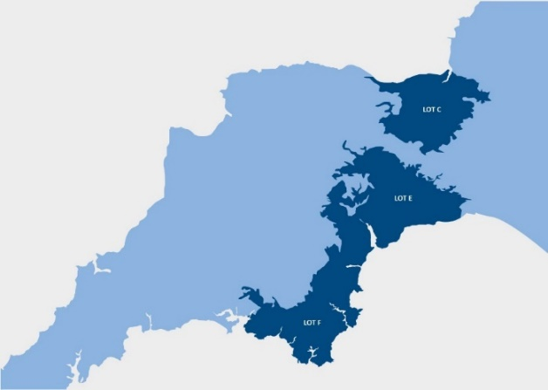
Lynda Sudlow
COMMUNITY LIAISON EXECUTIVE
Email : lynda.sudlow@airband.co.uk
Tel : 07399 050 349

